Low Level Design

**Deloitte Case Study**

|  |  |
| --- | --- |
| **Written By** | Ashish Rai |
| **Document Version** | **1.0** |
| **First Revised Date** | **20/10/2024** |
|  |  |
|  |  |

**DOCUMENT CONTROL**

**Change Record:**

|  |  |  |  |
| --- | --- | --- | --- |
| **VERSION** | **DATE** | **AUTHOR** | **COMMENTS** |
| 1.0 | 20 Oct 2024 | Ashish Rai |  |
|  |  |  |  |

**Reviews:**

|  |  |  |  |
| --- | --- | --- | --- |
| **VERSION** | **DATE** | **REVIEWER** | **COMMENTS** |
|  |  |  |  |

**Approval Status:**

|  |  |  |  |  |
| --- | --- | --- | --- | --- |
| **VERSION** | **REVIEW**  **DATE** | **REVIEWED BY** | **APPROVED**  **BY** | **COMMENTS** |
|  |  |  |  |  |

**Contents**

**1. Introduction........................................................................................................................ 04**

**1.1 What is Low-Level Design Document? ....................................................................... 04**

**1.2 Scope ............................................................................................................................ 04**

**2. Functional Architecture...................................................................................................... 05**

**3. Architecture Description ................................................................................................... 07**

**3.1 Data Description .......................................................................................................... 07**

**3.2 Data Transformation .................................................................................................... 11**

**3.3 Power BI Configuration ............................................................................................... 11**

**3.4 Deployment ................................................................................................................. 12**

# Introduction

## What is Low-Level design document?

The goal of the LDD or Low-level design document (LLDD) is to give the internal logic design of the actual program code for the Expenditure Data Analysis dashboard. LDD describes the class diagrams with the methods and relations between classes and programs specs. It describes the modules so that the programmer can directly code the program from the document.

## Scope

Low-level design (LLD) is a component-level design process that follows a step-by step refinement process. The process can be used for designing data structures, required software architecture, source code and ultimately, performance algorithms. Overall, the data organization may be defined during requirement analysis and then refined during data design work.

# Architecture

**Power BI Desktop Architecture**

1. **Get Power BI Desktop**

With Power BI Desktop, you can build advanced queries, models, and reports that visualize data. You can also build data models, create reports, and share your work by publishing to the Power BI service. Power BI Desktop is a free download.

1. **BI solution architecture in the Centre of Excellence**

BI solution architecture can consist of:

* + Data sources
  + Data ingestion
  + Big data / data preparation
  + Data warehouse
  + BI semantic models
  + Reports

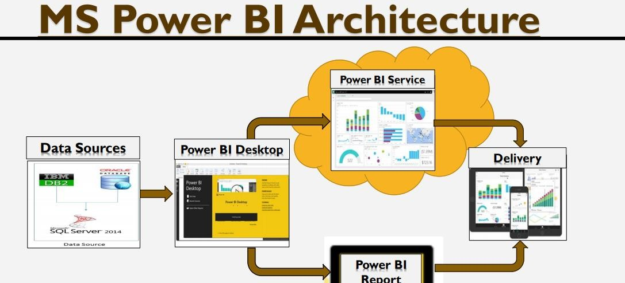

Fig: Power BI Architecture diagram

**Microsoft Power BI Desktop is a companion desktop application to Power BI.**

With Power BI Desktop, you can:

1. **Get data:**

The Power BI Desktop makes discovering data easy. You can import data from a wide variety of data sources. After you connect to a data source, you can shape the data to match your analysis and reporting needs.

1. **Create relationships and enrich your data model with new measures and data formats:**

When you import two or more tables, oftentimes you'll need to create relationships between those tables. The Power BI Desktop includes the Manage Relationships dialog and the Relationships view, where you can use Autodetect to let the Power BI Desktop find and create any relationships, or you can create them yourself. You can also very easily create your own measures and calculations or customize data formats and categories to enrich your data for additional insights.

1. **Create reports:**

The Power BI Desktop includes the Report View. Select the fields you want, add filters, choose from dozens of visualizations, format your reports with custom colours, gradients and several other options. The Report View gives you the same great report and visualizations tools just like when creating a report on PowerBI.com.

1. **Save your reports:**

With the Power BI Desktop, you can save your work as a Power BI Desktop file. Power BI Desktop files have a .pbix extension.

1. **Upload or publish your reports:**

You can upload the reports you created and saved in the Desktop to your Power BI site. You can also publish them to Power BI right from Power BI Desktop.

1. **Architecture Description**

**3.1. Data Description**

The Dataset contains three datasets CPI, EXPORTS and EXCHANGE monthly details on different countries for different year.

**CPI**

Consumer Price Index (CPI) is one of the most popular measures of inflation and deflation. It measures the average change in prices.

**EXPORTS**

Exports are defined as movable goods produced within the boundaries of one country, which are traded with another country. The sale of these goods generates foreign currency earnings in the country that produces them and boosts its economic growth. The greater the proportion of exports in relation to a country’s Gross Domestic Product (GDP), the larger the boost will be to overall growth when overseas demand increases.

**EXCHANGE**

In finance, an exchange rate is the rate at which one currency will be exchanged for another currency. There are many ways to measure an exchange rate. The most common way is tomeasure a bilateral exchange rate. A bilateral exchange rate refers to the value of one currency relative to another. Bilateral exchange rates are typically quoted against the US dollar (USD), as it is the most traded currency globally.

**INFLATION**

Inflation is the percentage change in the value of the Wholesale Price Index (WPI) on a year-on year basis. It effectively measures the change in the prices of a basket of goods and services in a year. In India, inflation is calculated by taking the WPI as base.

Inflation is often used to describe the impact of rising oil or food prices on the economy. For example, if the price of oil goes from $75 a barrel to $100 a barrel, input prices for businesses will increase and transportation costs for everyone will also increase. This may cause many other prices to rise in response.

## 

## Benefits of Inflation:

When the economy is not running at capacity, meaning there is unused labor or resources, inflation theoretically helps increase production. More dollars translate to more spending, which equates to more aggregated demand. More demand, in turn, triggers more production to meet that demand.

British economist John Maynard Keynes believed that some inflation was necessary to prevent the Paradox of Thrift. This paradox states that if consumer prices are allowed to fall consistently because the country is becoming too productive, consumers learn to hold off their purchases to wait for a better deal. The net effect of this paradox is to reduce aggregate demand, leading to less production, layoffs, and a faltering economy.

Inflation also makes it easier on debtors, who repay their loans with money that is less valuable than the money they borrowed. This encourages borrowing and lending, which again increases spending on all levels.

Pros of inflation:

* Leads to higher resale value of assets
* Optimum levels of inflation encourage spending

Cons of inflation:

* Buyers have to pay more for products and services
* Impose higher prices on economy
* Drives some prices up first and others later

Formula of inflation:

**Inflation Rate** = ((B – A) / A) x 100

Where,

A = starting cost

B = ending cost

**Global Data has raised its global inflation rate forecast for the end of 2022 by 2.7 percentage points, reaching 7.5%\***

**Year of Year (YOY)**

Year-on-year growth rates are rates of change expressed over the corresponding period (month or quarter in relation to the frequency of the data) of the previous year.

## Benefits of YOY:

YOY measurements facilitate the cross comparison of sets of data. For a company’s first-quarter revenue using YOY data, a financial analyst or an investor can compare years of first-quarter revenue data and quickly ascertain whether a company’s revenue is increasing or decreasing.

Pros of YOY:

* Minimizes the impact of seasonality on projections by comparing two static points in time
* Objectifies volatile values by comparing overall results
* Offers a simple calculation most people can do easily
* Results are formatted as percentages easy to understand, compare and draw quick insight from

Cons of YOY:

* The insights gained are improved by repeating the procedure over multiple points in time
* It's not valuable to provide insight into individual months where performance could be improved
* Is completely negated if one point of data expresses negative growth

Formula of YOY:

**Year-over-year Growth** = [(This Year – Last Year) / Last Year] X 100

**Compound annual growth (CAGR)**

The compound annual growth rate (CAGR) is the annualized average rate of revenue growth between two given years, assuming growth takes place at an exponentially compounded rate.

Benefits of CAGR:

The CAGR can be used to calculate the average growth of a single investment. As we saw in our example above, due to market volatility, the year-to-year growth of an investment will likely appear erratic and uneven.

Pros of CAGR:

* CAGR is an important tool which is used to measure the performance or profitability of any investment.
* As it considers the period of investment, it helps in providing a better understanding of the performance of the investment or the company in comparison to another.
* This helps in making accurate investment decisions which can result in higher profitability for the investor.

Cons of CAGR:

* CAGR does not consider market fluctuations or market volatility while evaluating the performance of any stocks. This is a hurdle in getting the true picture of the performance of such stock and can mislead the investor in making any investment decision.
* CAGR cannot be used as the sole basis to make investment decisions related to stock markets. Investors have to consider other parameters that incorporate the risk involved on account of market volatility and have to accordingly make their investment decisions.
* CAGR does not reflect on the short-term variations in the market and hence cannot be used as sole yardstick to make an investment decision between two funds or portfolios.

Formula of CAGR:

**CAGR=**(BVEV )n1 −1×100

Where,

EV=Ending value

BV=Beginning value

n=Number of years

**3.2. Data Transformation**

In the Transformation Process, we will convert our original datasets with other necessary attributes format. Originally datasets are in the form of wide dataset we converted into long datatype which will be useful for analysis Removing of NaN values and duplicate values. Conversion of monthly data into quarterly and yearly data. Filtering data according to countries

**3.3. Power BI Configuration**

**Step 1: Configuring Data Source**

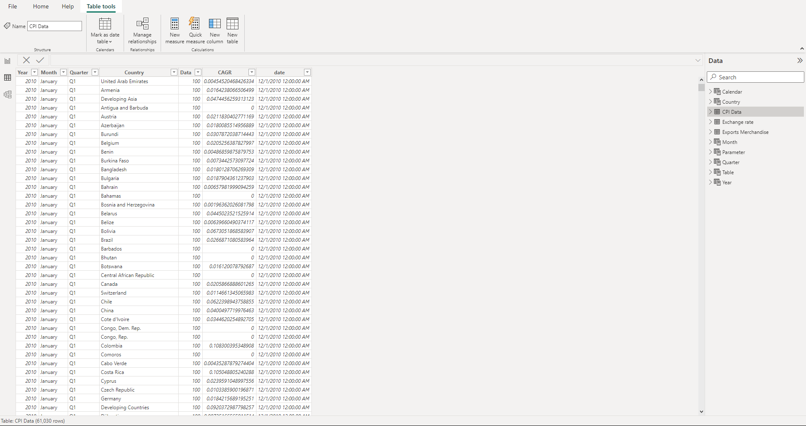

**Step 2: Filtering the data**

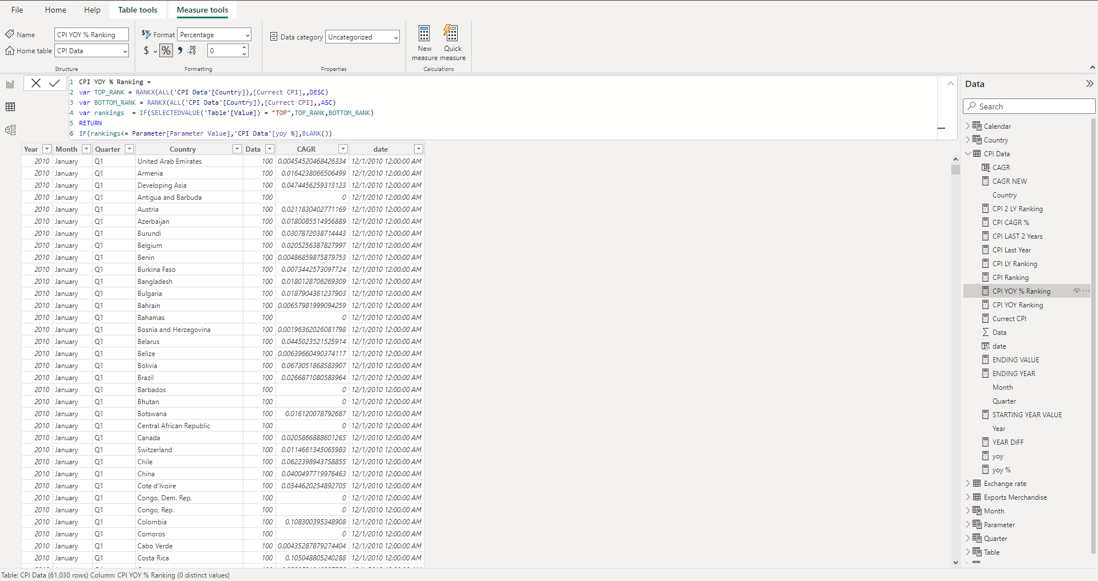

**3.4 Deployment**

To deploy the dashboard to the Power BI service, you need a Power BI Pro or Power BI Premium account. With the appropriate account, you can publish your Power BI Desktop file (.pbix) to the Power BI service directly from Power BI Desktop. Click on the "Publish" button, sign in with your Power BI account, and select the workspace where you want to deploy the dashboard.